Question 2:

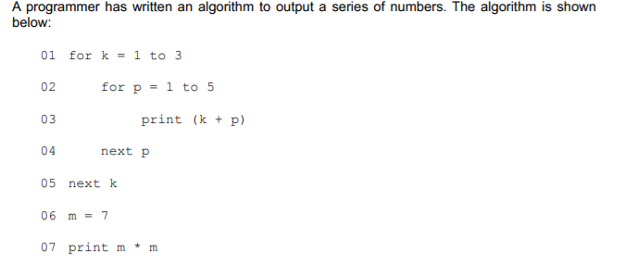

1. **Give the first three numbers that will be printed by this algorithm. [1 mark]**

2, 3, 4

1. **State how many times line 03 will be executed if the algorithm runs through once. [1 mark]**

4 or 5 depending on whether “for p = 1 to 5” is exclusive or not.

1. **Identify two basic programming constructs that have been used in this algorithm. [2 mark]**

Iteration, variables.

1. **Describe what is meant by a variable? [2 mark]**

Name to refer to a piece of data stored in a computer.

1. **Identify two variables that have been used in the algorithm above.[2 marks]**

m, p